INSTALLING JUPYTER NOTEBOOK

Step 1 – Install Python 3 on your local device

Step 2 – Install the Python 3 package for Jupyter Notebook:
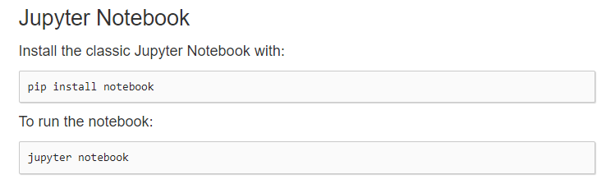
https://jupyter.org/install

Step 3 – Create a local directory to store the notebooks
Step 4 – Download the notebooks from SUN Learn into this directory
Step 5 – Open command prompt, change to your notebook directory (created in step 3), and run jupyter notebook.
